**Trip to India – Venue Analysis**

* ***Introduction:***

Bob who lives in London, UK has got a month vacation in the month of December. He decided to go on a trip to India along with his family. But he is not sure which part of India he should visit this time. His friends suggested that southern state of India, with the coastal regions would match up to his expectations and can have lot more fun and experience Indian culture. His colleagues suggested that northern India surrounding Himalayan ranges would match his climate and trip can be very adventurous with hill trekking and bungee jumping. Now, he confused with which one to choose. Let us make explore about the Indian tour places in both Northern and southern India and let us give a road map to Bob to make his decision.

* ***Data requirements:***

Based on the interest, let us select 5 places each in northern and southern India as the neighborhood. As like everyone, for a trip, we would be looking for the below amenities in the selected neighborhood.

1. Climate
2. Hotel accommodation
3. Transport
4. Restaurants nearby the tourism spot

* ***Data Collection:***

We will be relying on the Foursquare data to get the nearby venues to analyze the Hotel, transportation details and restaurants nearby. And let us use the public data over the internet for analysis the Indian climate during the month of December.

* ***Methodology:***

We will use Foursquare data to get the most common nearby venue details and do some exploratory analysis. Later we will apply k-means clustering method to analyze the top 3 restaurants which are nearby the tourist locations.

* ***Data Preparation:***

As suggested earlier, based on Bob’s personal interest, let us select 5 places in northern and southern part of India each. And for us to analyze further, we get us get the latitude and longitude co-ordinates [we these data is not readily available over the internet we have used excel file] and our interested data details is as follows

|  |  |  |  |  |  |
| --- | --- | --- | --- | --- | --- |
| **Place** | **Location** | **State** | **Category** | **Latitude** | **Longitude** |
| Alapuzha | South | Kerala | Backwater | 9.5013 | 76.33232 |
| Munnar | South | Kerala | Hills | 10.08187 | 77.06294 |
| Athirapalli | South | Kerala | Falls | 10.2851 | 76.5697 |
| Mahabalipuram | South | TamilNadu | Architecture | 12.62693 | 80.19271 |
| Mysore Palace | South | Karnataka | Palace | 12.29581 | 76.63938 |
| Tirumala | South | Andha | Temple | 13.63551 | 79.41989 |
| Leh & Ladakh | North | Jammu&Kashmir | Mountain | 34.14473 | 77.55612 |
| Darjeeling | North | West Bengal | Hill | 27.03941 | 88.26387 |
| Rishikesh | North | Dehradun | Bungee jumping | 30.08639 | 78.26658 |
| Kasi(Ganges) | North | West Bengal | River | 25.31765 | 82.97391 |
| Taj Mahal | North | Delhi | Site | 27.17389 | 78.04207 |

* ***Exploratory Data Analysis:***

Let us first see what are the places that we are interested in using the Folium map generator

.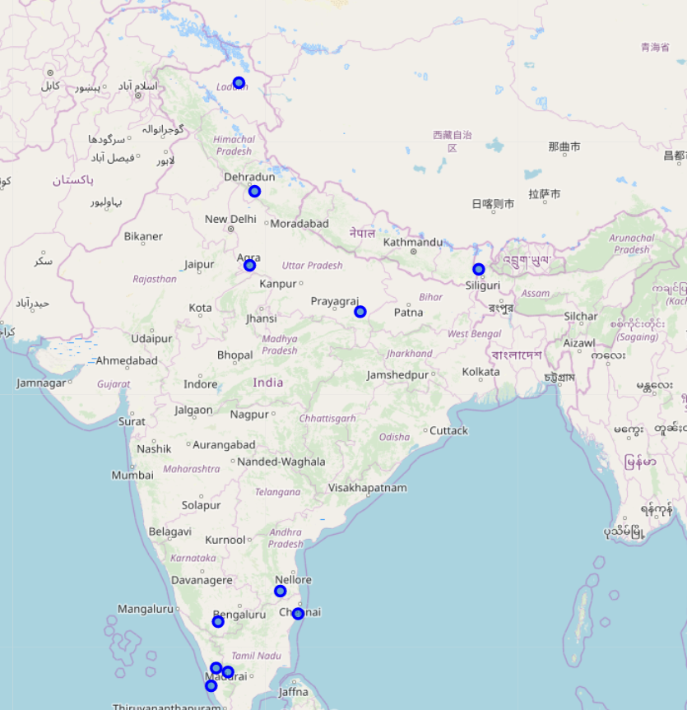

Now using Foursquare API, lets us get the top 100 venues nearby in the 10km radius of our interested tour attraction sites. Based on the result of our query, we will analyze venues surrounding each neighborhood and get more details about each place’s hotel, transportation amenities and Restaurants.